Sr. No.
Application fee of Rs. 2000/- for General and Rs.1000/- for Reserved Category
Paste
PASSPORT SIZE
PHOTO
(Only on main Form)
(Do not staple)

Employment Notice No. SGBAU/1/103/------/2026, dt.------ Last Date of receipt of application- ----------
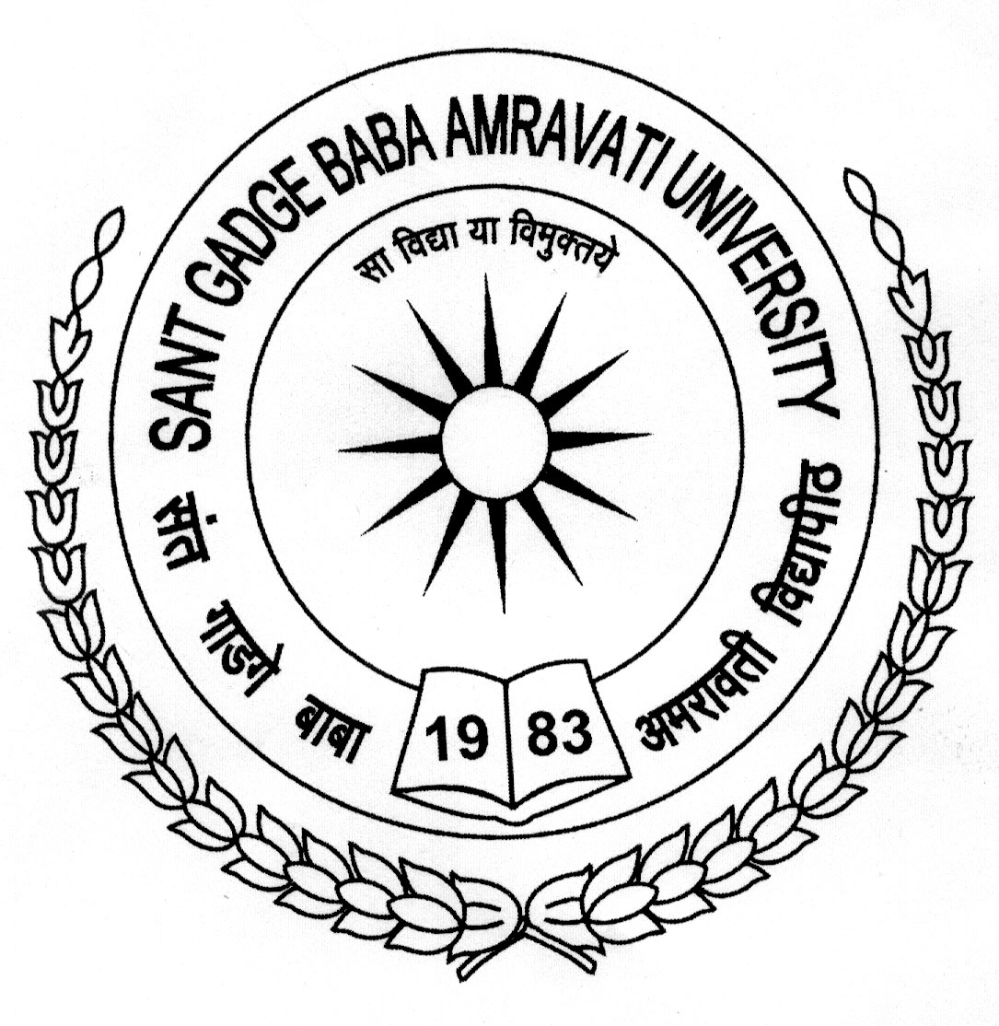
SANT GADGE BABA AMRAVATI UNIVERSITY

APPLICATION FORM
(Read carefully the complete advertisement, particulars, instructions and application form before filling it)

APPLICATION FOR THE POST OF : DEAN
IN THE FACULTY OF : _________________________________________
IN THE CATEGORY (RESERVATION) : _________________________________________
1) Name in Full : __________________________________________________________________________________
(Surname first) (in Capital Letters)
___________________________________________________________________________________
2) Address for correspondence: ___________________________________________________________
________________________________________________________________________________
__________________________________________________________________________________
Phone No.: (Residence): ___________________ (Office) _____________ (Mob.)_________________
E-mail: ____________________________________________

3) Permanent Address: ________________________________________________________________
_________________________________________________________________________________
________________________________________________________________________________
4) Nationality: __________________ State of Domicile________________________________
5) (a) Date of Birth : ________________________
(b) Present Age: Years: _____________ Months: ________________ Days: ___________
(Attach true copy of S.S.C. Board Certificate OR Leaving Certificate)
6) Whether member of SC/ST/ VJ/NT/SBC/OBC? YES / NO
If yes, specify – CATEGORY: __________________________ CASTE: _____________________
(Attach true copy of the Caste Certificate & certificate of validity issued from the competent authority as designated by the Govt .of Maharashtra)
7) Educational Qualifications (Please attach Mark Sheets/ Degree Certificates in chronological order)
Exams/  Degrees | Name of Examination | University/  Board | Division | Attempts | Year of  Passing | % of marks obtained | Major subjects offered  (specialization, if any) | Merit/  Prizes/  Medals conferred
Ph.D. (Relevant)
M.Phil. (Relevant)
P.G.
(Relevant)
U.G.
H.S.S.C.

S.S.C.

Others

-2-

8) Particulars of Teaching Experience in University/College, and/or experience in research at the University/National level institutions/Accredited Research Institution/industry, if any. The span of time taken by candidates to acquire M.Phil. and /or Ph.D. Degree shall not be considered as teaching experience:
(Attach true copies of Certificates of the employer mentioning details as below.)
Name of the Institution/ College/ Industry | Post-held with pay scale /  pay band + AGP or Pay Matrix + Level | Teaching/Research/Industrial Experience
Name of the Institution/ College/ Industry |  | Under Graduate |  | Post Graduate
Name of the Institution/ College/ Industry |  | From | To | From | To
i) Under-Graduate _________ Years ii) Post Graduate __________ Years

Consolidated Experience (taken together) _________Years

9) Particulars of Contribution to educational innovation, design of new curricula and courses, and technology –mediated teaching learning process:
__________________________________________________________________________________________________________________________________________________________________________________________________________________________________________________________________
10) Administrative Experience, if any, in chronological order.(Attach certificate/s)
Post Held &  Name of Department /  Institution | Pay Scale /  Pay Band + AGP or Pay Matrix+ Level | From | To | Total Period | Reasons  For  leaving

11) Period required for joining, if appointed : ________________________________

12) A) Minimum pay, if the initial pay is : ________________________________
not acceptable.
B) Whether demand of enhanced pay is : ________________________________
a request or condition?

DECLARATION

I, __________________________________________________ hereby declare that all the information given above is true to the best of my knowledge and belief. I am not aware of any circumstance, which may impair my eligibility for employment in Sant Gadge Baba Amravati University. I have never been disqualified / debarred from appearing in any University Examination / University Work. I have never been dismissed from University / College / Government Service.
Place:
__________________________
Date: Signature of Applicant

-3-

(To be furnished by the candidate who is already in service)
NO OBJECTION CERTIFICATE
Certified that Dr./Shri./Smt./Ku. ___________________________________________ is working as ______________________ in the subject _______________________ in the Deptt. of ____________________ w.e.f. ________________ in the Pay Matrix Academic Level ______________________________ drawing the basic pay of Rs. __________________ This Office has no objection if he/she is selected for the post of ______________________ in the Sant Gadge Baba Amravati University and will be relieved within the stipulated period.

Place:
Date: _______________________________ Signature of employer/Competent Authority with designation & Seal
--------------------------------------------------------------------------------------------------------------------------------
DECLARATION
FORM – A

(See Rule 4 of the Maharashtra Civil Services (Declaration of Small Family) Rules, 2005)

I, Shri / Smt. / Kum. _____________________________________________________________ son / daughter /wife of Shri __________________________________________, aged __________ years resident of__________________________________________ do hereby declare as follows :-
1. That I have filled my application for the post of ____________________________________
2. I have ____________________ (Number) living children as on today. Out of which No. of children born after Dt.28.3.2005 is _________________________ (mention dates of birth, if any).
3. I am aware that, if any total number of living children is more than two due to the children born after dt.28.3.2005, I am liable to be disqualified for the same post.

Signature of Applicant
--------------------------------------------------------------------------------------------------------------------------------
IMPORTANT INSTRUCTIONS FOR FILLING UP OF AN APPLICATION FORM FOR THE TEACHING / OTHER POSTS OF THE UNIVERSITY.

1. Please read carefully University Direction Nos. 8/2019, 14/2019, 17/2019 & 50/2019.
2. This form is to be submitted in 05 similar copies. (One in original & 04 photocopies (Good Quality)). All the papers, enclosures and Form of Application in uniform Legal size would be preferred.
3. The attested True copies of Mark sheets, Experience Certificates, Caste Certificate, No Objection Certificate & other relevant testimonials shall be attached to all copies of APPLICATION FORM.
4. Candidates applying through proper channel should obtain No Objection Certificate from the present employer provided in application form.
5. These forms should be punched centrally by punching machine and tied using a Tag or Lace only; spiral binding, stapling, binding in a Book Form should be avoided.
6. Passport size Photograph is to be pasted on Main Application Form only. Do not staple.
7. Person sending Advance Copy of the Application Form should send only one copy complete in all respect. Five Copies are not expected, in such cases.
8. Candidates applying for the same post in two different categories, i.e. OPEN & B.C. should submit their applications separately. Common Application Form for two categories or two posts shall not be considered.
9. LIST OF ENCLOSURES: Please list and attach copies of certificates, Caste Validity, Experience Certificates, etc. related to the information given in the Application Form serially as per sequential column Nos.
-4-

SANT GADGE BABA AMRAVATI UNIVERSITY

PART B : ACADEMIC PERFORMANCE INDICATORS
CATEGORY : I

TEACHING, LEARNING AND EVALUATION RELATED ACTIVITIES

I. Direct Teaching (Lectures/ Practicals/ Tutorials/ Field Work / Project Supervision taken should be based on verifiable records.).
Sr. No. | Course/Paper | level | Mode of  teaching* | Hours allotted  per week | Hours Engaged | Percentage of lectures engaged/ conducted | Grading | Proof Document**
Odd Semester
1
2
3
4
5
6
7
8
9
Even Semester
10
11
12
13
14
15
16
17
18
* Lecture (L), Tutorial (T), Practical (P), Field Work (FW), Project Supervision (PrS)
Grading Criterion:- 80% and above – Good; Below 80% but 70% and above- Satisfactory; Less than 70%- Not satisfactory.

**As per table under the document Annexure I (A)
Overall Grading ( Category : I ) :-

___________________
Signature of Teacher

-5-

SANT GADGE BABA AMRAVATI UNIVERSITY

PART B : ACADEMIC PERFORMANCE INDICATORS
CATEGORY : II
Involvement in Administrative, Examination, Co-curricular, Extension and Professional Development Related Activities.

II i. Administrative Responsibility.
Sr. No. | Responsibility | Nature of Work | Grading | Proof Document**
1.
2.
3.

II ii. Contribution to corporate life through committees and duties assigned by the authority.
Sr. No. | Responsibility | Nature of Work | Grading | Proof Document**
1.
2.
3.

II iii. Examination Work:
Sr. No. | Responsibility | Nature of Work | Grading | Proof Document**
1.
2.
3.

II iv. Discipline related co-curricular activities:
Sr. No. | Responsibility | Nature of Work | Grading | Proof Document**
1.
2.
3.

II v. Other co-curricular activities:
Sr. No. | Responsibility | Nature of Work | Grading | Proof Document**
1.
2.
3.

II vi. Extension and dissemination activities:
Sr. No. | Responsibility | Nature of Work | Grading | Proof Document**
1.
2.
3.

-6-
II vii. Institutional governance:
Sr. No. | Responsibility | Nature of Work | Grading | Proof Document**
1.
2.
3.

II viii. Conduct of Lectures:
Sr. No. | Responsibility | Nature of Work | Grading | Proof Document**
1.
2.
3.

II ix. Participatory and Innovative Learning:
Sr. No. | Responsibility | Nature of Work | Grading | Proof Document**
1.
2.
3.

II x. Evidence of actively involved in guiding Ph.D. students:
Sr. No. | No. of Ph.D. Students Registered | No. of Ph.D. Students submitted Thesis | No of Students Awarded Ph.D. Degree | Grading | Proof Document**
1.
2.
3.

II xi. Conduct of Research Projects:
Sr. No. | Title of Project | Major/ Minor | Period of Award | Amount Approved | Name of Funding Agency | Grading | Proof Document**
1.
2.
3.

II xii. Research paper Published:
Sr.No. | Title with page nos. | Journal | ISSN /  ISBN No. | Whether peer reviewed Impact Factor,  if any | No. of co- authors | Whether you are the main author | Whether Refereed / other Journal as notified by the UGC# | Grading | Proof Document**
1
Total

Grading Criteria:- Good - Involved in at least 3 Activities; Satisfactory- 1-2 activities and
Not-satisfactory - Not involved/ undertaken any of the activities.

**As per table under the document Annexure II (A)
Overall Grading ( Category : II ) :-

----------------------------
Signature of Teacher

-7-

SANT GADGE BABA AMRAVATI UNIVERSITY

PART B : ACADEMIC PERFORMANCE INDICATORS
CATEGORY : III
RESEARCH, PUBLICATIONS AND ACADEMIC CONTRIBUTIONS

III A. Research Papers publication:

Sr. No. | Title with page nos. | Journal | ISSN /  ISBN No. | Whether peer reviewed Impact Factor,  if any | No. of co- authors | Whether you are the main author | Whether Refereed / other Journal as notified by the UGC# | Augmented API Score | Proof Document**
1
Total

III B.a. Publications other than journal articles (books, chapters in books):

Sr.  No. | Title with page nos./ Chapter with page no. | Book Title,  editor &  publisher | Publication International/ National/ Local | ISSN/ ISBN No. | Whether approved by University | No. of co- authors | Whether you are the main author | API Score | Proof Document**
1
Total

III B.b. Publications in the form of Cassettes/CDs/DVDs, Tracks published/ Recorded:

Sr.  No. | Cassettes/CDs/DVDs, Tracks published/ Recorded | Company | Publication International/ National/ Local | Whether approved by University | No. of artists | Whether you are the main artist | API Score | Proof Document**
1
Total
III B.c. Publications in the form of individual Cassettes/CDs/DVDs, Tracks published/ Recorded:

Sr.  No. | Individual Cassettes/CDs/DVDs, Tracks published/ Recorded | Company | Publication International/ National/ Local | Whether approved by University | API Score | Proof Document**
1
Total
III C. Creation of ICT mediated pedagogy and content and
development of new and innovative courses and curriculA

Sr.  No. | Innovative Pedagogy/ New Curricula/ Courses/ MOOCs/ E-Content | Name of Activity | Authority Concern | Publisher | Course Credit/ Module | API Score | Proof Document**
1
Total
III D.a RESEARCH GUIDANCE:
Sr. No. | Number Enrolled | Thesis Submitted | Degree awarded | API Score | Proof Document**
M. Phil.
Ph. D.
P.G. Dissertation
Total
-8-

III D.b RESEARCH PROJECTS Completed:

III D. b (i). Sponsored Projects:

Sr.  No. | Title | Agency | Period | Grant / Amount  Mobilized  (Rs lakh) | Policy Document Generated | API Score | Proof Document**
1
 | Total

III D.b (ii). Consultancy Projects:

Sr.  No. | Title | Agency | Period | Grant / Amount  Mobilized  (Rs lakh) | Policy Document Generated | API Score | Proof Document**
1
 | Total

III D.c ONGOING RESEARCH PROJECTS:

III D.c (i). Sponsored Projects:

Sr.  No. | Title | Agency | Period | Grant / Amount  Mobilized  (Rs lakh) | API Score | Proof Document**
1
Total
III D. c (ii). Consultancy Projects:

Sr.  No. | Title | Agency | Period | Grant / Amount  Mobilized  (Rs lakh) | API Score | Proof Document**
1
Total

III E.a Patents Awards:
Sr. No. | Title of Patents | Award conferring Organization | National/ International | Patent Number | API Score | Proof Document**
1
2
3
Total

III E. b Policy Document:
Sr. No. | Title of Document | Policy Document Submitted to | International/ National/ State Government/ Central Government | Publisher | API Score | Proof Document**
1
2
3
Total
-9-

III E. c. Fellowships and Awards:

Sr. No. | Fellowship/ Award | Award conferring Organization | Event Organized by | Whether international /  national / state / regional / college or university  level | API Score | Proof Document**
1
2
3
Total

III F. Invited lectures / Paper delivered in conferences / seminars:
Sr. No. | Invited Talk/ Paper  presented | Title of  Conference / Seminar | Event Organized by | Whether International (Abroad) / International (Within Country) National / State / Regional / College or University  level | API Score | Proof Document**
1
2
3
Total

Note:
- Paper presented if part of edited book or proceeding then it can be claimed only once.
- For joint supervision of research students, the formula shall be 70% of the total score for Supervisor and Co-supervisor. Supervisor and Co-supervisor, both shall get 7 marks each.
- *For the purpose of calculating research score of the teacher, the combined research score from the categories of 5(b). Policy Document and 6. Invited lectures/Resource Person/Paper presentation shall have an upper capping of thirty percent of the total research score of the teacher concerned.

**As per table under the document Annexure III (A)

Total Score ( Category : III ) :-

___________________
Signature of Teacher
IV. SUMMARY OF Grades/ API SCORES
Category | Criteria | Last Academic. | Grades / API | Annual API Score for Category III Only
I | Assessment Criterion for Teaching, Learning and Evaluation Related Activities
II | Involvement in Administrative, Examination, Co-curricular, Extension and Professional Development Related Activities
III | Research and Academic Contribution

___________________
Signature of Teacher

-10-

SANT GADGE BABA AMRAVATI UNIVERSITY

PART C : OTHER RELEVANT INFORMATION
Please give details of any other credential, significant contributions, awards received etc. not mentioned earlier.
Sr.No. | Details (Mention Year, value etc. where relevant)
1
2
3
4
5
6
7
8
9
10
*Annexure-IV

LIST OF ENCLOSURES: (Please attach, copies of certificates, sanction orders, papers etc. wherever necessary)
1.
2.
3.

I certify that the information provided is correct as per records available with the University / College and / or documents enclosed along with the duly filled PBAS proforma.

Signature of the Candidate with
Designation, Place & Date

-11-

SANT GADGE BABA AMRAVATI UNIVERSITY

Statement showing particulars of applicant for the post of DEAN

Category ________________________

Name & Correspondence Address of the Applicant with Contact No. & E-mail ID | Age/Date of Birth | Category  (Caste) | Academic Attainments |  |  |  | Experience ( Yr./ Month/ Days) |  |  | Publication, if any | API Score  (if applicable) | Any other Information, if any
 | Age/Date of Birth | Category  (Caste) | Degree Awarded | Year of Passing | %/ CGPA | Div./ Grade | Teaching | Research | Admin. | Publication, if any | API Score  (if applicable) | Any other Information, if any
 |  |  |  |  |  |  |  |  |  | International :
 |  |  |  |  |  |  |  |  |  | Own:-
 |  |  |  |  |  |  |  |  |  | Joint :-
 |  |  |  |  |  |  |  |  |  | Total :-
 |  |  |  |  |  |  |  |  |  | National :
 |  |  |  |  |  |  |  |  |  | Own:-
 |  |  |  |  |  |  |  |  |  | Joint :-
 |  |  |  |  |  |  |  |  |  | Total :-

I hereby declare that all the entries made by me are true to the best of my knowledge and belief. If anything is found false at any stage, my candidature for the Post of ___________ may be cancelled without assigning any reason thereof.

Date : _____________________ Signature of Applicant : __________________________

Place : ____________________ Name of Applicant : ______________________________

